Short Term Open Access - User Manual for Applicants

Su Created by – PricewaterhouseCoopers Pvt. Ltd.

Contents
1. Introduction 3
2. Registration of Applicant 4
2.1. Applicant Registration 5
2.2. Password reset: 6
2.3. Applicant Details: 9
3. Types of Applications 11
A. Application Creation 12
A.1 Contigency/ Day Ahead/ FCFS/Advanced Applications 12
A.2 Application Processing 16
A.3 Application Withdraw 20
B. E – bidding (Applicant) 20
C.Downward Revision 23
C.1 Request Creation : 24
4. Payments 25
4.1 Payment > Payment Dashboard: 25
1.1.1 Details Dashboard 29
1.1.1 Summary Dashboard: 30
1.1.2 Application Dashboard: 30
1.1.3 Excess Payment Dashboard 29
1.1.4 Interest Payment Dashboard: 32
4.2 Payment > Monthly: 34
Monthly TDS Updation: 35
Key Contact Personnel 36

Introduction

With the enactment of the Electricity Act, 2003 (Act), power sector reforms were set in motion. Among the gamut of initiatives, power trading along with provision of implementation of Open Access was introduced as an activity distinct from generation, transmission, and distribution of power. Trading of power is further segregated into long term, medium term and short term based on open access granted to the participants. Provision of open access provides for non-discriminatory use of transmission and distribution facilities thereby enabling participants to choose buyer/seller of their own choice.
To provide a web based solution for the STOA workflow consisting of online application submission, processing of applications and sending approvals online, including sending and receiving consents from other RLDCs and SLDCs. It provides a fast, transparent and convenient service to the customers and stakeholders of RLDC. This software reduces paper work, aims at avoiding human pro errors and assists in serving the customers effectively. It assists in application processing, calculation of payments and distribution of payments to CTUs, STUs, RLDCs and Applicants (for Refund). The Nodal RLDC will interact online with other RLDCs, for their consents.

Registration of Applicant

When a user opens the Website, user gets to see the Landing Page with four options on the top left corner.
- Home :
  - Clicking on the Home link, user will be navigated to the Home Page of the Website.
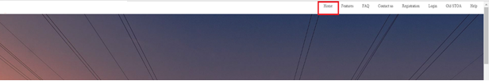

- Registration :
- Clicking on this link user will be navigated to Registration page for both Applicant and Utility.
  - Clicking on the radio button-Applicant, user will be allowed to register as a new Applicant to raise requests for power quantum allocation for a period of time.
  - Once an Applicant has registered, a Login ID and Password will be provided, using which applicant can log in to the website.
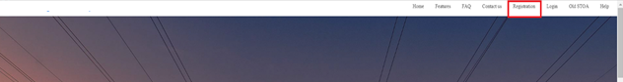

- Login:
  - Clicking on the Login link, user will be navigated to Login page.
  - User needs to click Login link to Log in to their individual account if they have already Registered themselves.
- Features: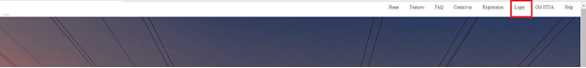We are able to view different features of the website upon clicking this tab.


- FAQ
- The frequently asked questions along with the answers are available here.
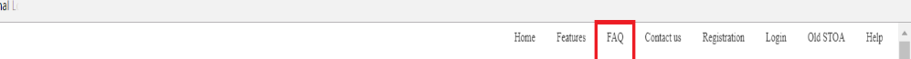
- Contact Us
- The contact of NRLDC is provided here.
- We can submit our message to NRLDC here.
- 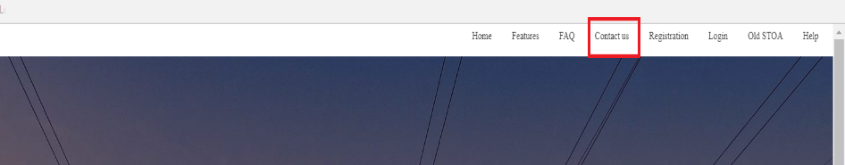

- Help
- We can download the user manual for help upon clicking this tab
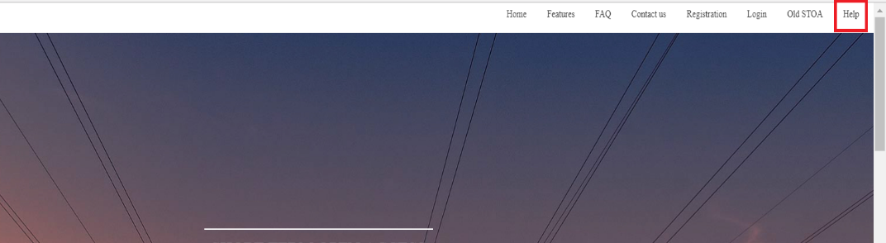

Applicant Registration
On the Login page the following fields and buttons will be available.

- Username :
Enter the Username that was confirmed via e-mail.
- Password :
Enter the Password.
- Remember Me :
Check the checkbox only in case you want your browser to remember your credentials.
- Forgot Password? :
To generate a New Password or Reset your Password, click on this link.
- Sign In :
Once the Username and Password has been entered, click on the Sign In button to log in to your individual account on ERLDC website.
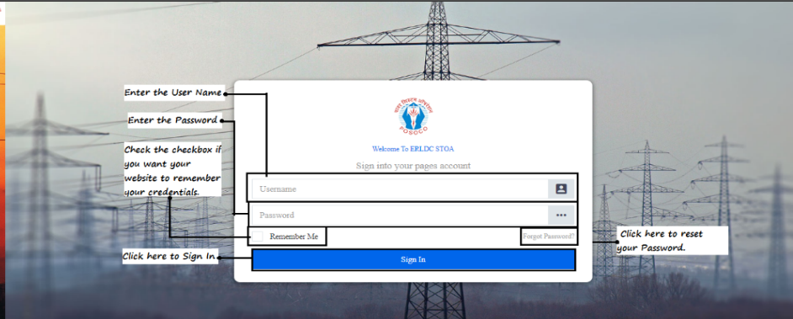

- Clicking on the Sign Up button will prompt the user for confirmation:
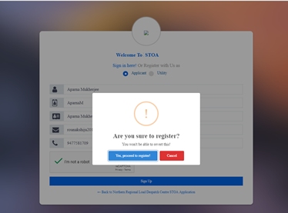

- On confirmation, it will show that the applicant has been successfully registered, and the credentials have been mailed to the provided e-mail id. Users will need to login using the credentials and fill up the details to complete their registration.
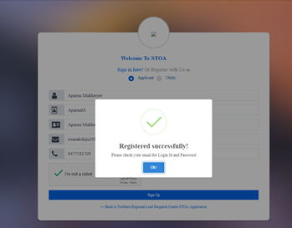

Password reset:
In case of Applicant when the user attempts to log into the portal for the first time, it asks to change the password.

- Click on the ‘Login’ Link at the top right corner of the page:
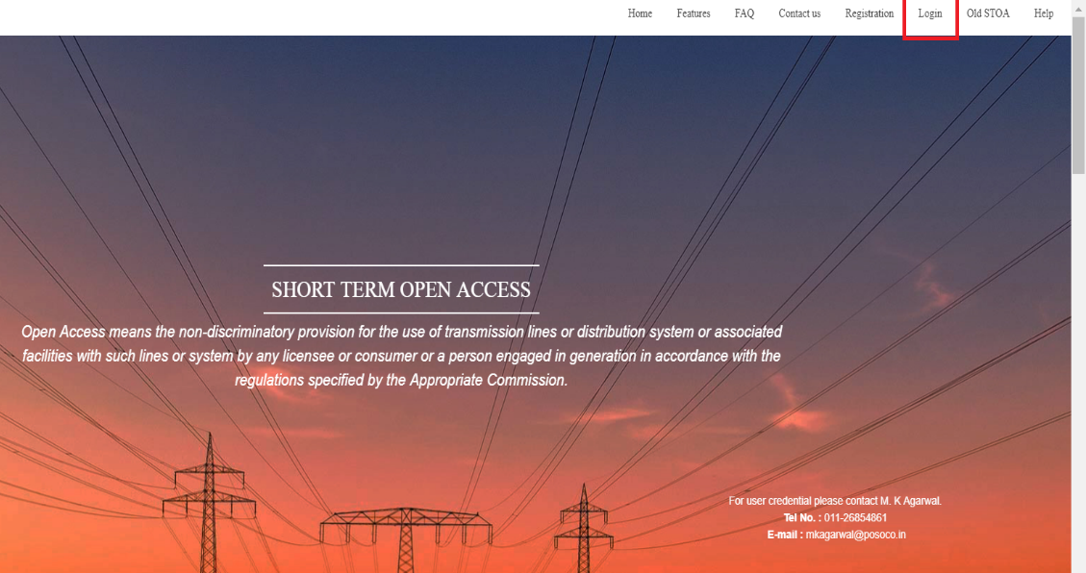

- Now enter the log in credentials received as in mail, and hit the ‘Sign in’ button:
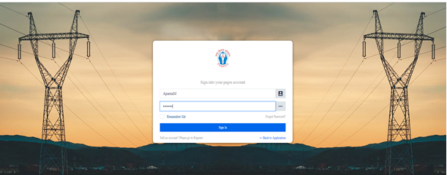

- This will take the user to a screen for changing the current password and reset a new one:
`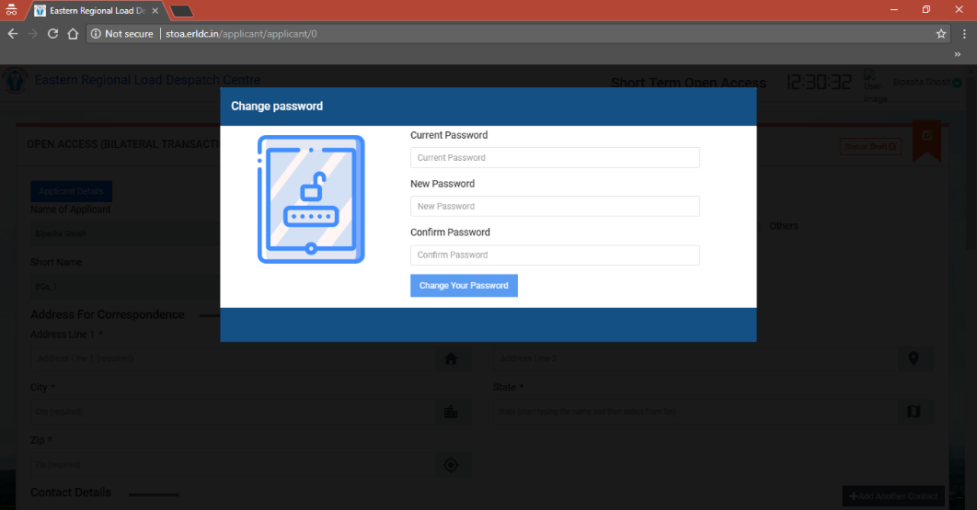

- As the user enters old and new passwords, reconmfirms the new one and hits the ‘Change your password’ button:
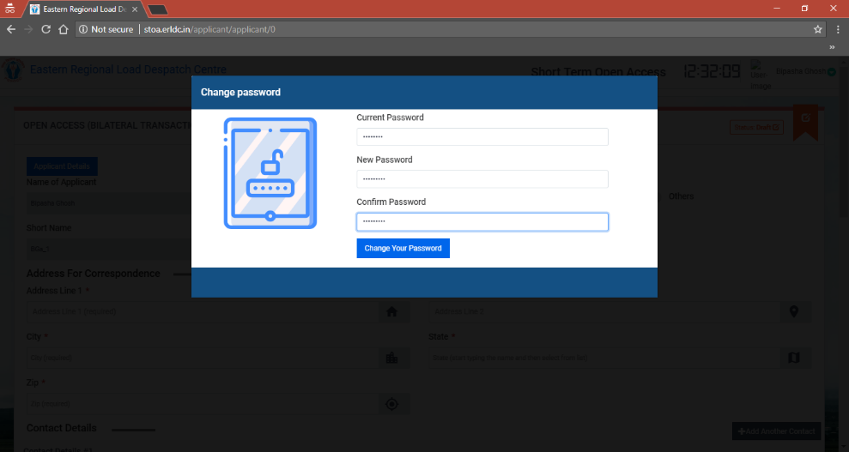

- It will show a message that the new password has been set for the applicant:
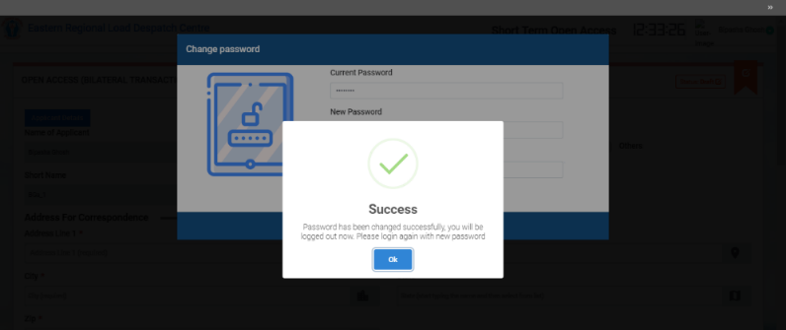

- Now the Applicant can log in with the new password and submit the application form to register itself in the portal as a user.

Applicant Details:

2.5.1 Applicant Details Submission:

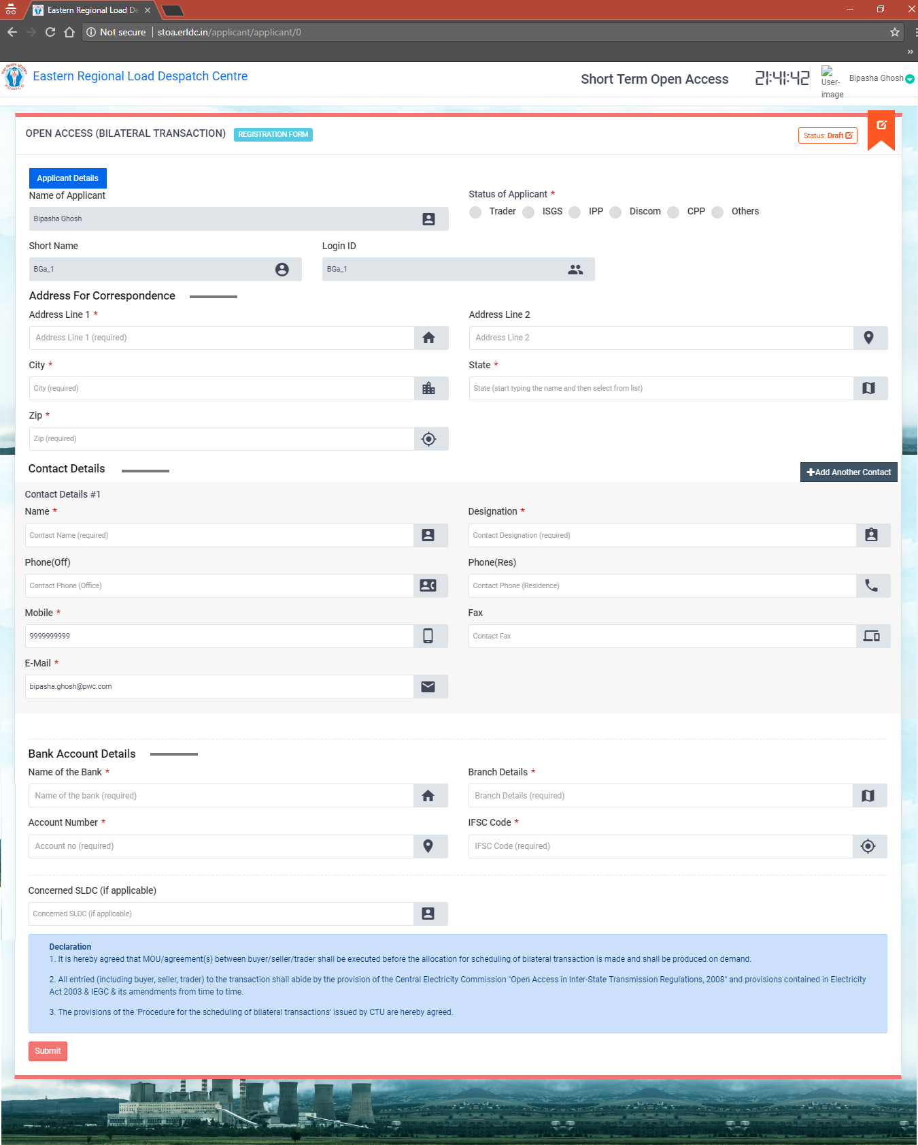

In the Applicant Registration form following sections will be present :
- Name of Applicant: To be auto-populated as filled in while registering the applicant.
- Short Name: To be auto-populated as filled in while registering the applicant.
- Login ID: To be auto-populated as filled in while registering the applicant.
- Status of Applicant: any of the following – Trader, ISGS, IPP, Discom, CPP or other.
- If trader is selected: Trading License Number and Trading License Type is to be filled. Along with that, trading license to be uploaded as well.
- If any of the other options are selected, it is required to select an already registered Utility.
- Address for correspondence: Mandatory field.
- Contact Details: Mandatory field.
- Bank Account details: Mandatory field
- Concerned SLDC details: If Applicable.

2.5.2 Reviewer Asked for More Info :
- Once the application is submitted, it goes to the Reviewer for approval. In case reviewer finds any information missing, the form can be sent back to the applicant asking to provide the necessary information.
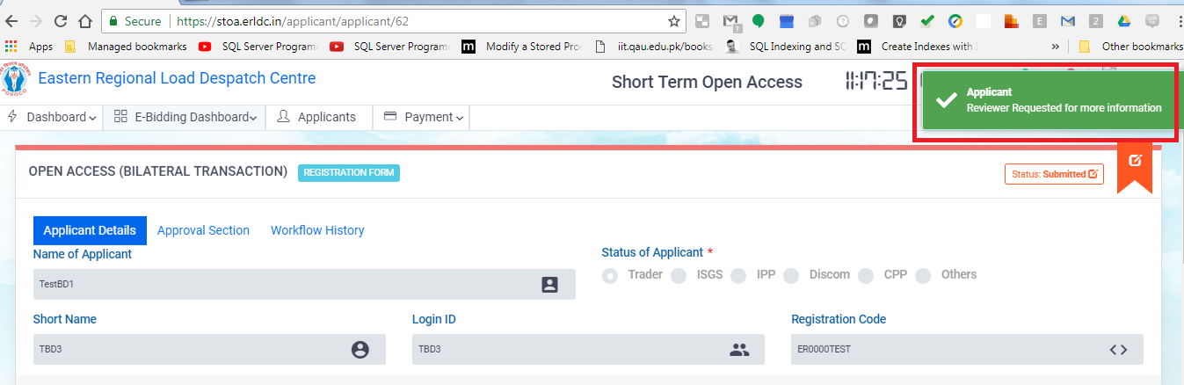
- Applicant will get a notification in its profile saying Reviewer has asked for more info.
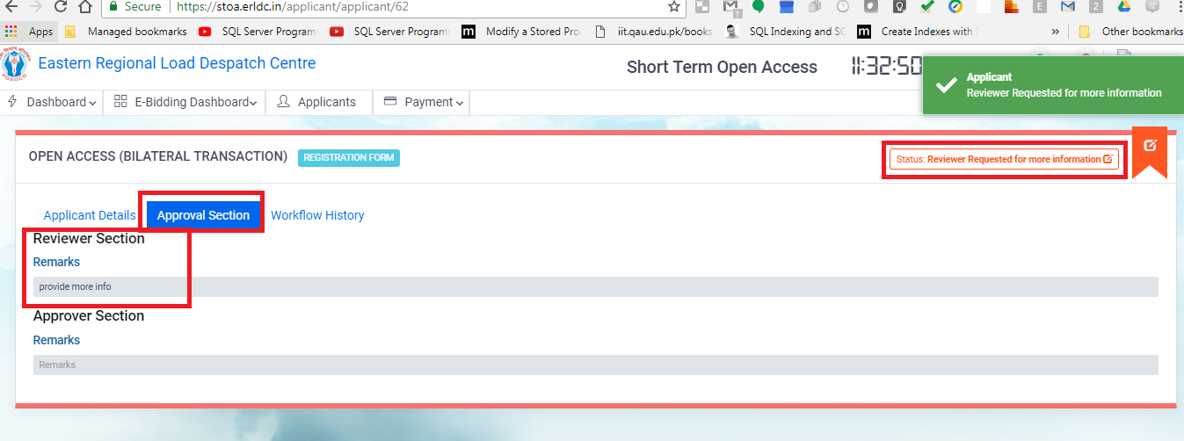
- Navigate to Approval Section tab and Reviewer’s comment will be found in the Approval Section.
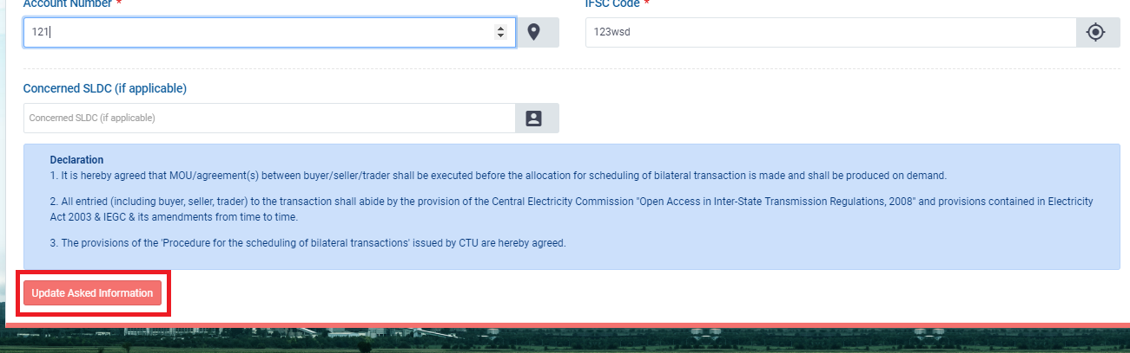
- Update the required information and click on Update Asked Information button.

2.5.3 Approver Asked for More Info :
- Once the application is approved by Reviewer, it goes to the Approver for approval. In case approver finds any information missing, the form can be sent back to the applicant asking to provide the necessary information.
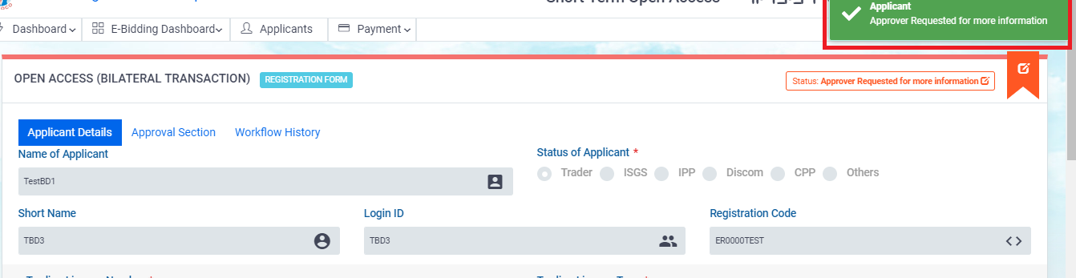
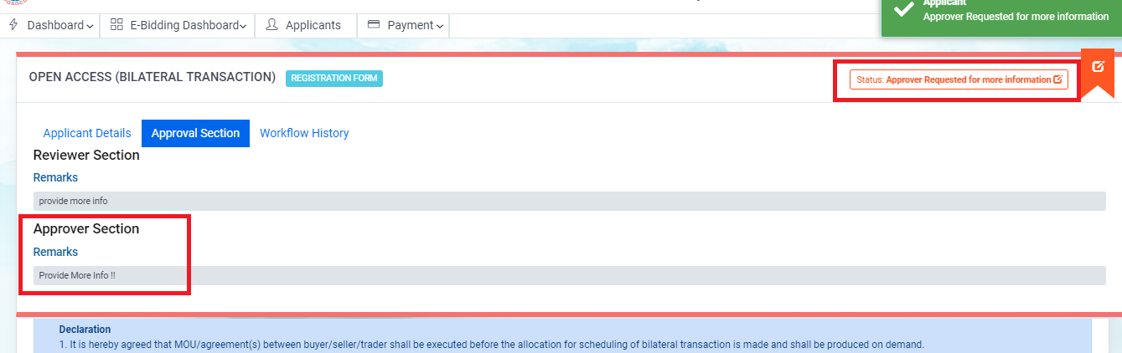
- Applicant will get a notification in its profile saying Approver has asked for more info.
Navigate to Approval Section tab and Approver’s comment will be found in the Approval Section.
- Update the required information and click on Update Asked Information button.

2.5.4 Registration Application Approved :
- Users will get notifications when their registration application gets approved by Reviewer and Approver.
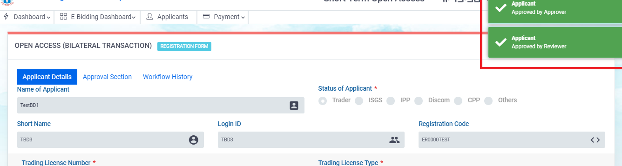
- Once the application is approved, applicant can create applications for power transmission.

25.5 Registration Application Rejected:

- In case Reviewer/Approver rejects the application, the status of the application will get updated as Rejected. User will get a notification that the application has been rejected.
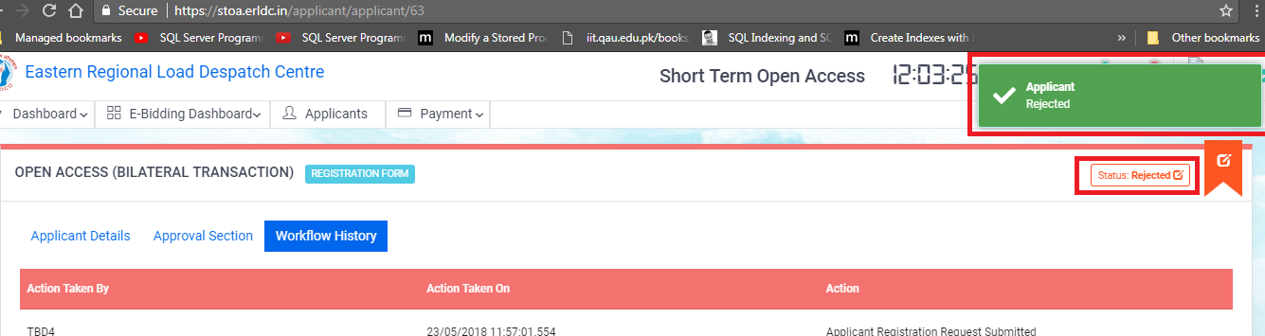

Types of Applications

Click ‘Login’ and enter the required registered credentials to access the application.
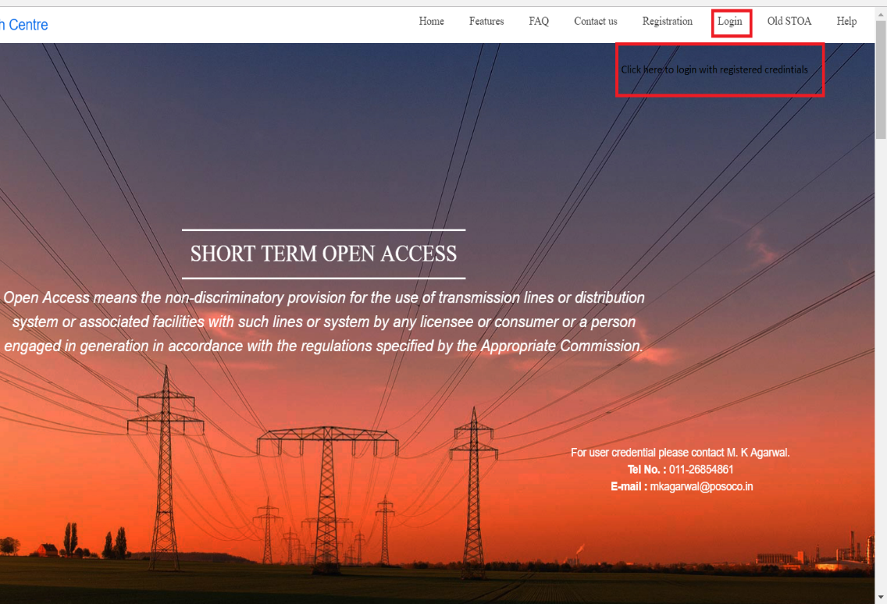

A. Application Creation

A.1 Contingency/ Day Ahead/ FCFS/Advanced Applications
- On the menu bar, click on the leftmost option, Dashboard --> Applications.
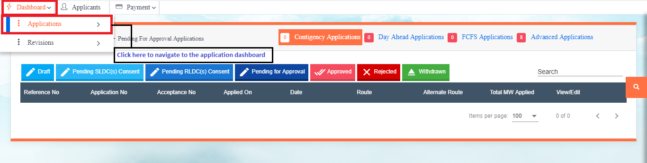

- On the Application Dashboard page, navigate through the Application Type tabs to track the applications.

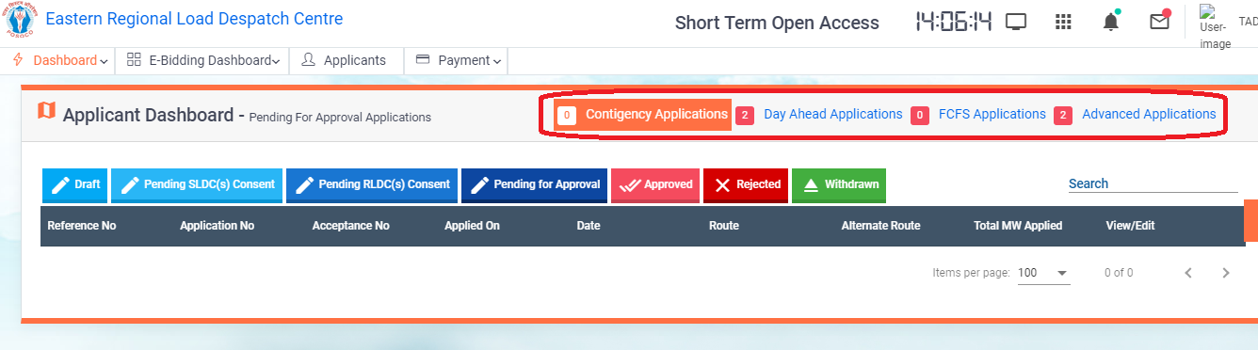

- Click on the (+) button at the right bottom corner to create a new application. Application can be any of the 4 types of applications i.e. Contigency, Day Ahead, FCFS and Advanced.

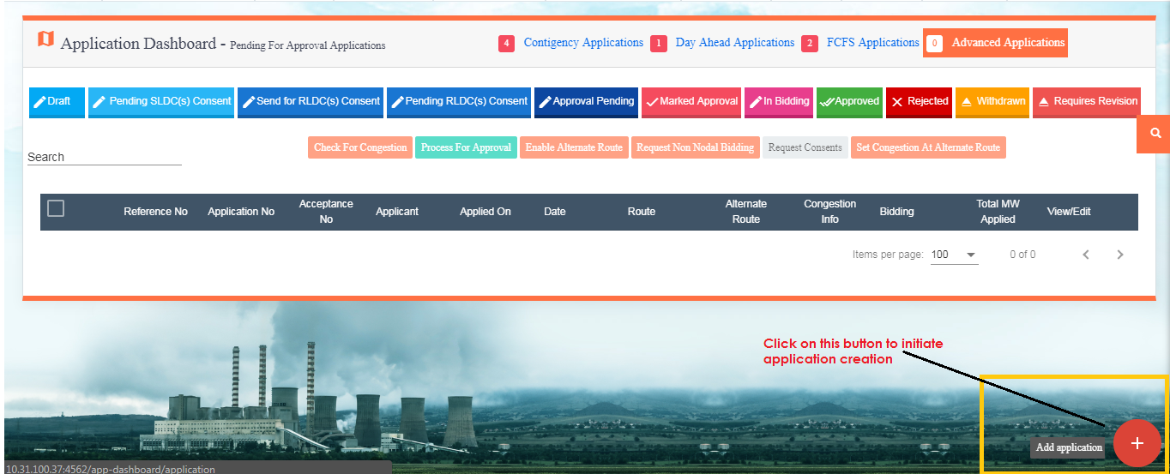

- A new application form opens up.
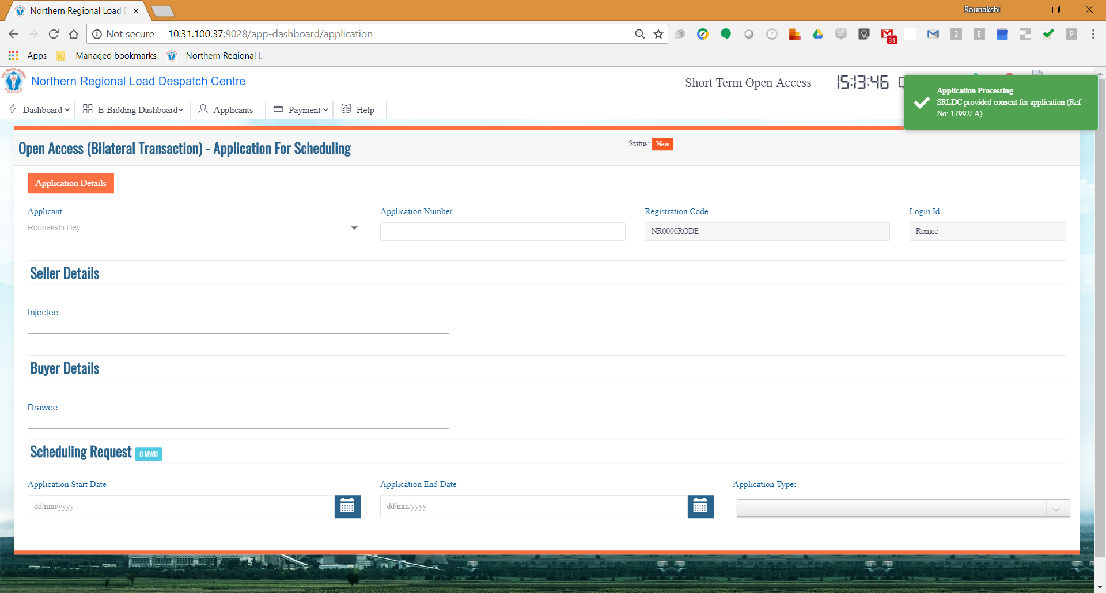

- The Applicant auto populates depending on the login credential.
Applicant Registration Code and LogIn ID gets autopopulated in accordance to the Applicant Name.
- Select the Start Date from and End Date of the Time Period for which the applicant wants to apply from the Application Start Date and Application End Date Calendar Controls.
- Depending on the Application Start Date and Application End Date selected, the Application Type will get autopopulated in the Application Type field.
- Contigency Application can be created for the current date on which the applicant is applying.
- If at the time of creating the application, it has already been past 15:00 in the clock, user can create application for the next day as well.
- Contigency Application though can be raised for a single day at a time.So, the application raised today for a time block tomorrow, will be treated with the applications raised for tomorrow’s date all at a time. (Speicific only for Contigency application)
- Enter the Seller and Buyer details from the dropdown.
- If SLDC consent is required to be uploaded for a particular Injectee or Drawee STU, a link to upload files will appear when the STU is selected in any of the Injectee or Drawee dropdown list.
- If the Applicant is not Trader, the STU mapped to the Applicant needs to be selected in any of the Injectee or Drawee field.

- 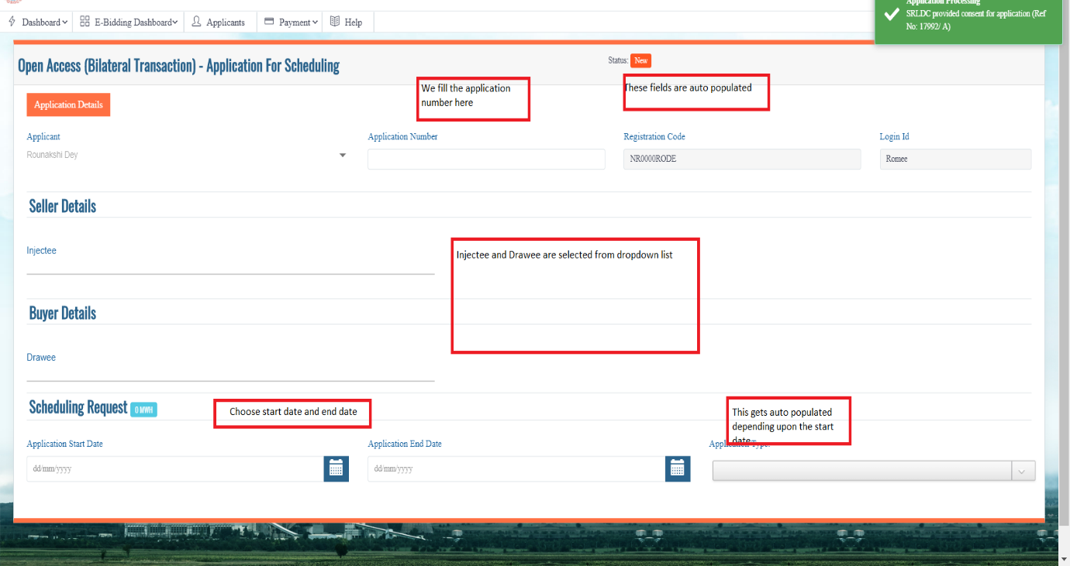

- Enter the start and end time of the time blocks for which the Applicant wants to apply from Start Time and End Time dropdowns in the grid.
- To add more than one timeblocks, click on the Add Row button. More rows will get added to the grid.
- To delete any row click on the Delete icon beside that particular row.
- After all the details about the required timeblocks have been entered click on the Validate button to check if the entries clear all the validation rules.
If all the validations pass the (!) icon beside Validation Status will change to (√).
If the entries fail any validation check, the details will be displayed beside the Validation Status text.
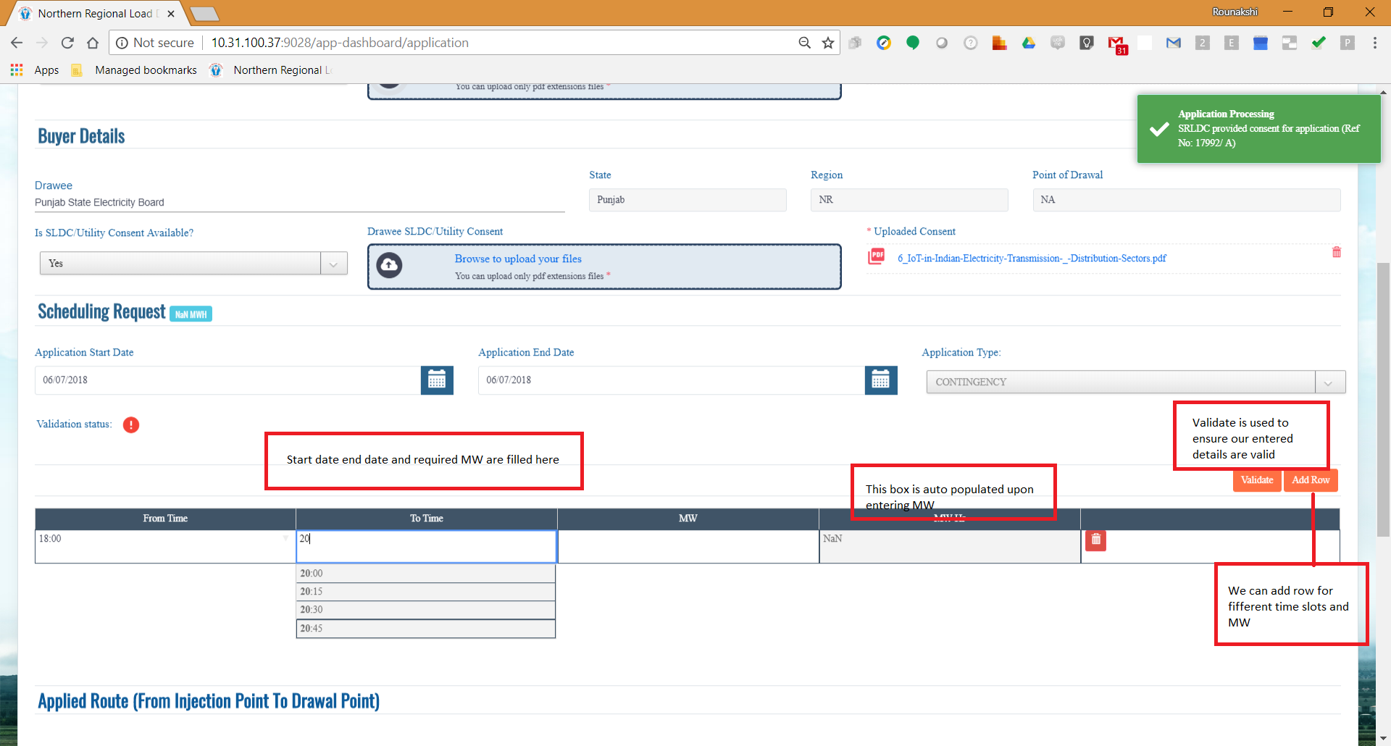
- According to the Injectee and Drawee Regions, possible routes via which the transmission can be done will populate in the Route Dropdown list. Select one route from the list.
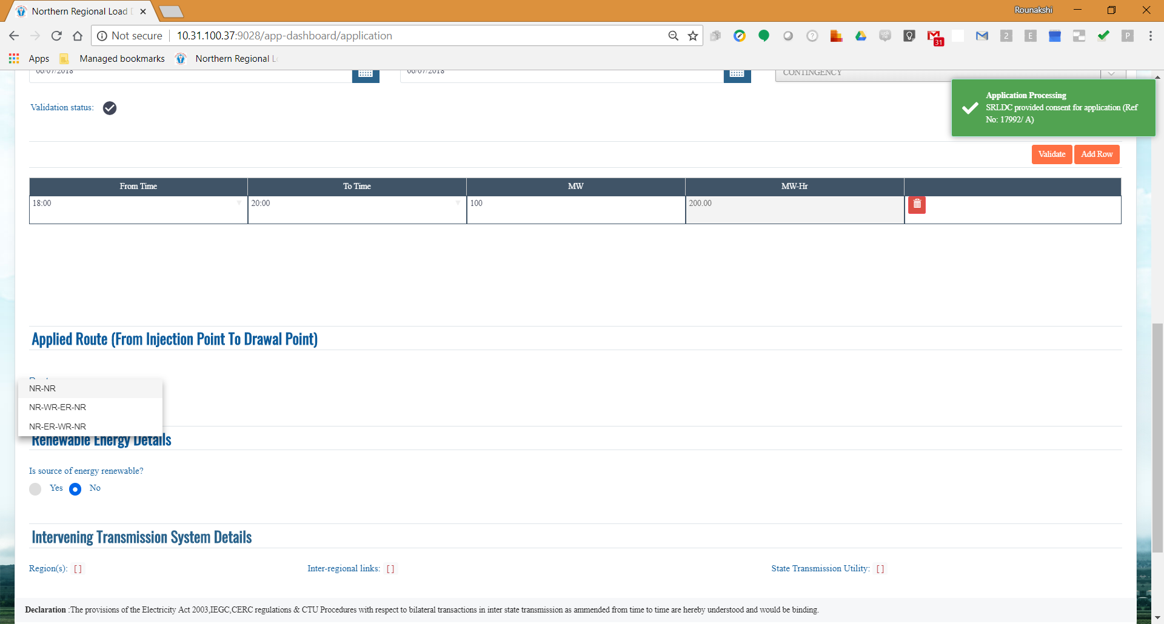
- The applicant chooses for whether renewable energy is transmitted.The default ‘NO’radio button is selected.If we choose yes radio button we need to provide the type of renewable energy to be transmitted among three options ,i.e,
- Solar
- Wind
- Other

- When all the required fields will be updated with required values, Save and Submit button will become enabled.

- Clicking on the Save button the application will be saved as draft so that the applicant can open it later and edit the application form before he/she submits. Until and unless an application is Submitted the application won’t be processed for approval.
- Click on the Submit button to submit the application. Once submitted the application cannot be edited anymore.
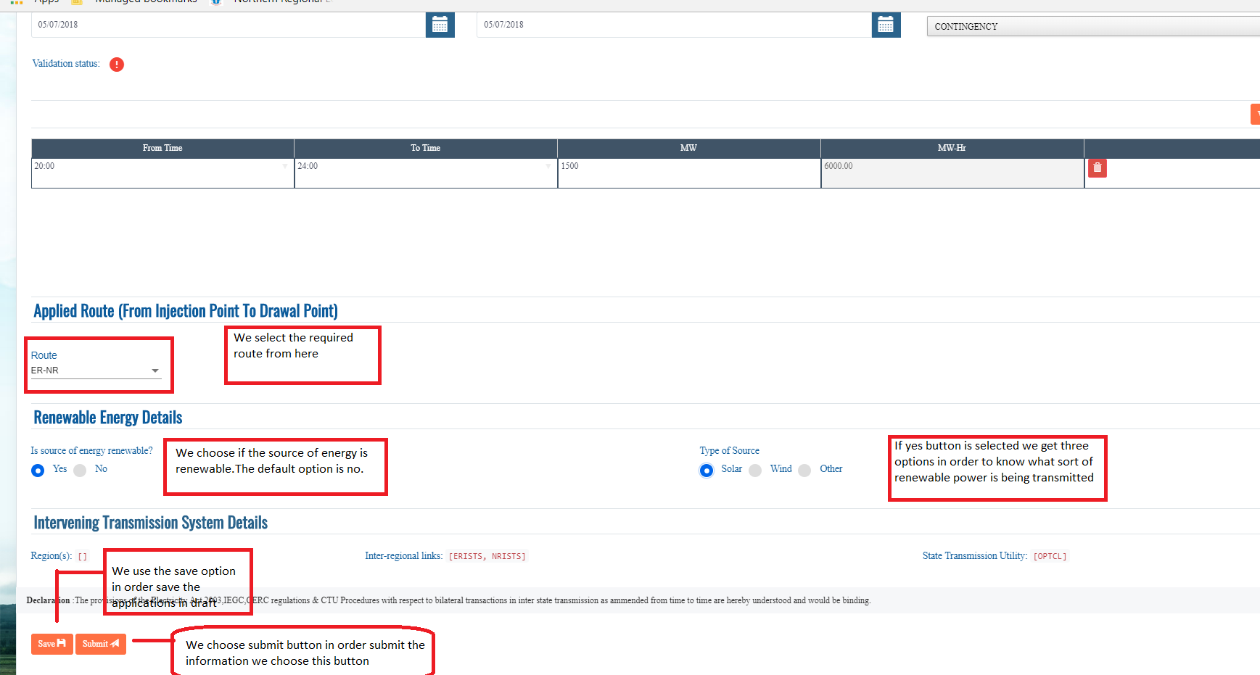

A.2 Application Processing
- To view and process Contigency Applications, click on the Contigency Application tab as shown before.

A.2.1 Pending SLDC(s) Consent :
- This view lists the applications which are pending for SLDC consent .
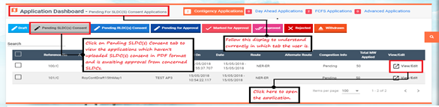

- Click on View/Edit option to open the application.

A.2.2 Pending RLDC(s) Consent :

- Click on Pending RLDC(s) consent tab to view applications which are awaiting approvals from concerned Non Nodal RLDCs.

- Click on View/Edit button to open the application.
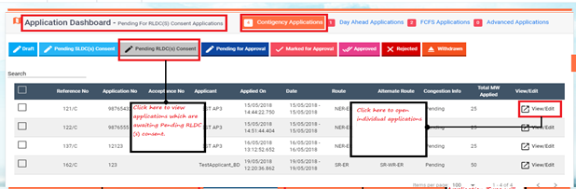

- Applicant can withdraw it’s application only till this phase, i.e. as long as the application is awaiting Non Nodal RLDC’s consent. Once the Non Nodal RLDC has approved the application the application further cannot be withdrawn.

- Scroll down the application. At the bottom of it the Withdraw button is available. Click on it to withdraw the application.
Once withdrawn, it cannot be undone anymore.
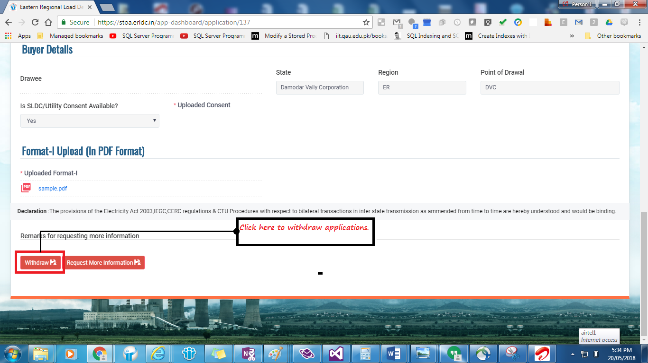

A.2.3 Pending for Approval:
- Click on Pending for Approval tab to view applications which are awaiting approvals from Nodal RLDC.
- Click on View/Edit button to open the application.
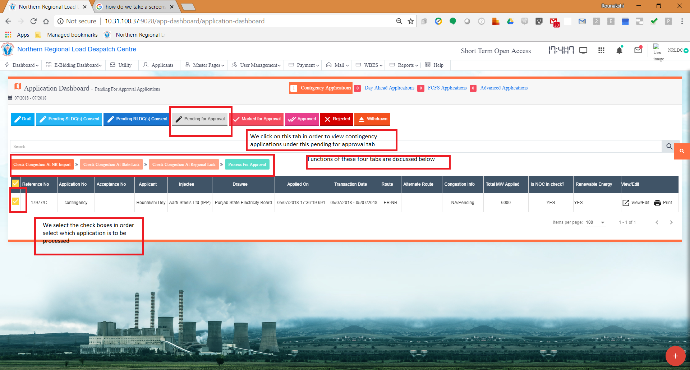

A.2.4 Approved:
Click on Approved tab to view applications which have been approved by Nodal RLDC.
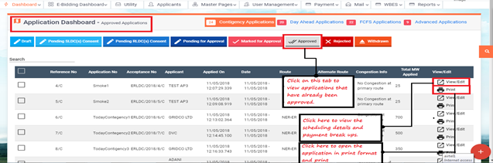

- Click on View/Edit button to open the application details. The details contain the Approved Scheduing section and Payment Breakup section.
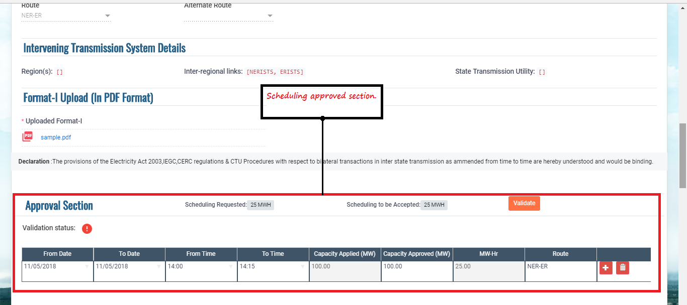
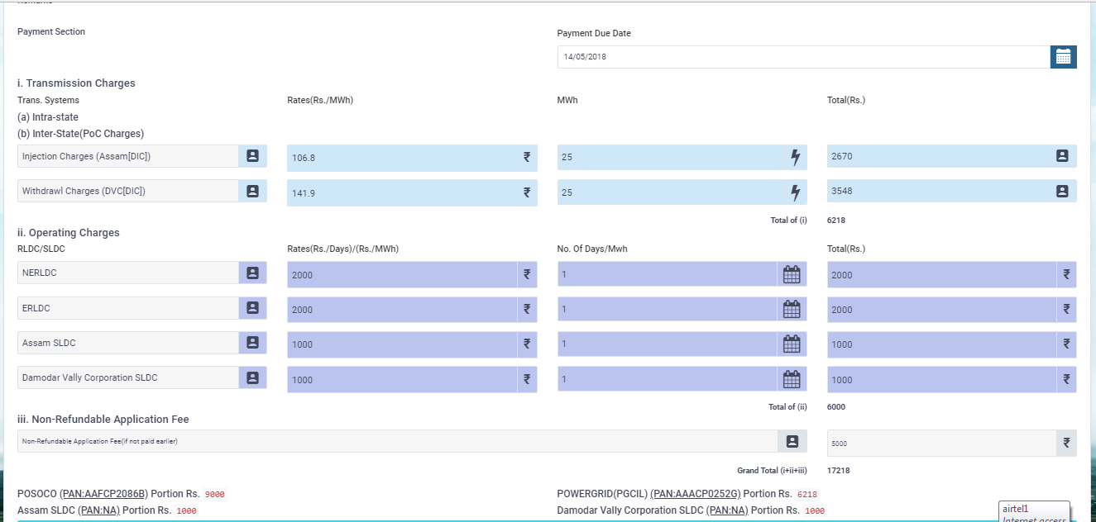


- On the right top corner there 2 icons of the application form :
: Click on this icon to open the application in PDF format and print.

: Click on this icon to open the application in Excel format.

A.2.5 Rejected :
- Click on this tab to view applications that has been rejected by Nodal RLDC.
- Click on View/Edit button to open the application details.
Note : Only Application Fee is charged in these applications.

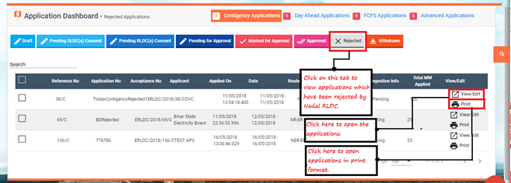

A.2.6 Withdrawn :
- Click on this tab to view applications that has been withdrawn by the applicant.
- Click on View/Edit button to open the application details.
Note : Only Application Fee is charged in these applications.
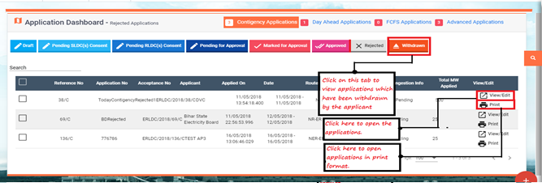

A.3 Application Withdraw
- Once an application is submitted, it can be withdrawn as long as the applications have not got consents from Non Nodal RLDCs.
- Once the applications have moved to Pending for Approval tab it cannot be withdrawn anymore.

- If applications are withdrawn, the Applicant will require to pay the Application Fee only.

- To withdraw an application, open the application by clicking on the View/Edit button in its row.

- Scroll down the application. At the bottom of it, the Withdraw button is available. Click on it to withdraw the application.

- Once withdrawn, it cannot be undone anymore.

B. E – bidding (Applicant)
After creation of the e-bidding window, appliants are able to view the records under E-bidding --> Applicant Dashboard.

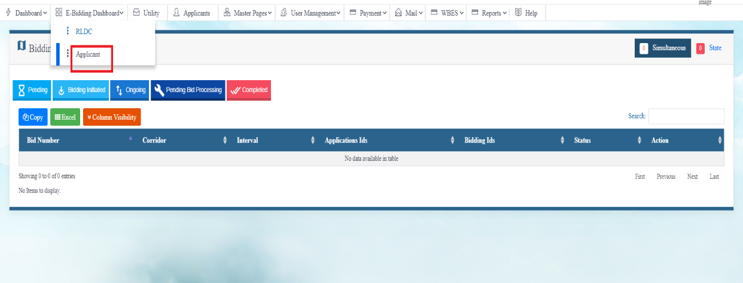

In the Applicant Bidding Dashboard, click on the bid-value-update button
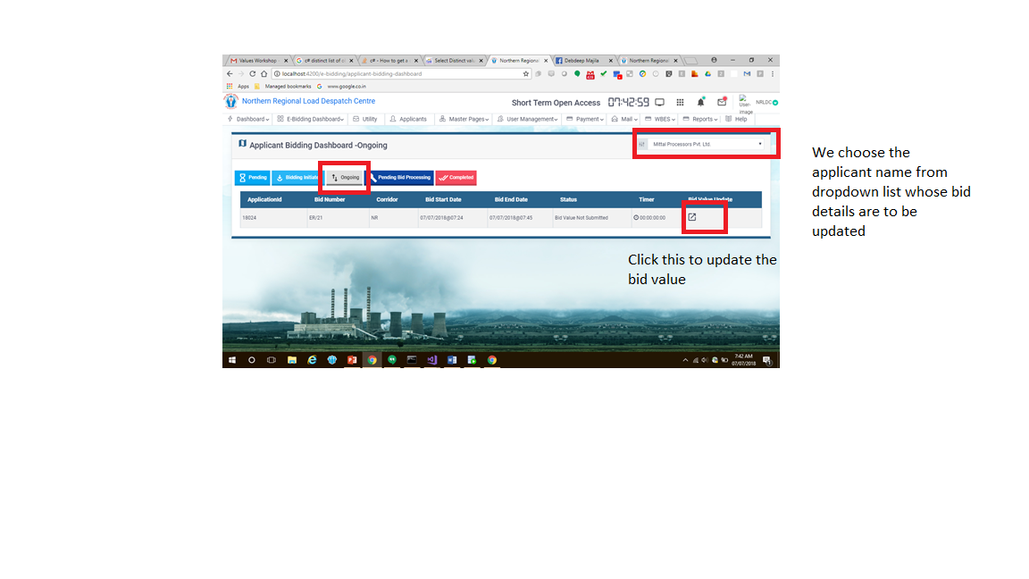

Fill the correct password available via mail
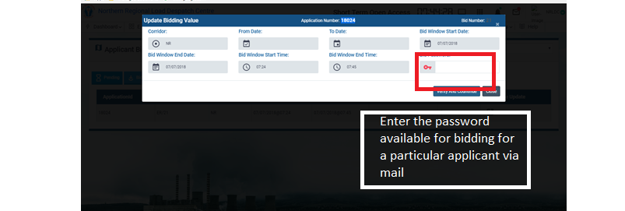
Upon entering the unique password and chossing ‘VERIFY AND CONTINUE’ button we see this screen

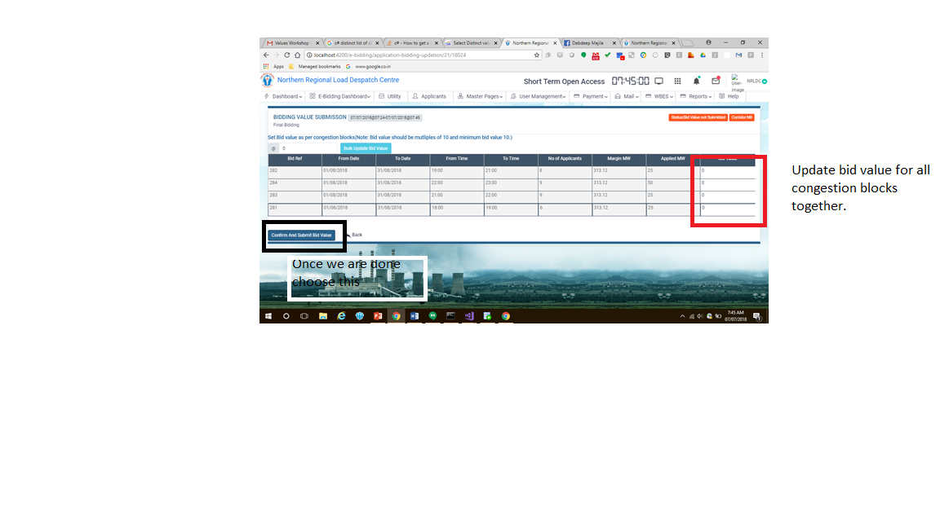

Upon choosing to submit we get this message
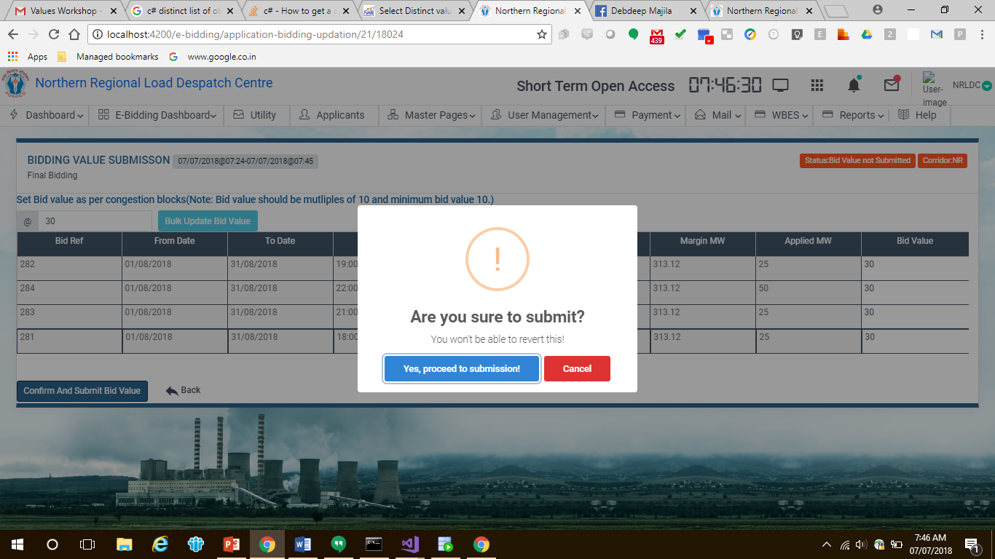
Once successfully submitted we get this message

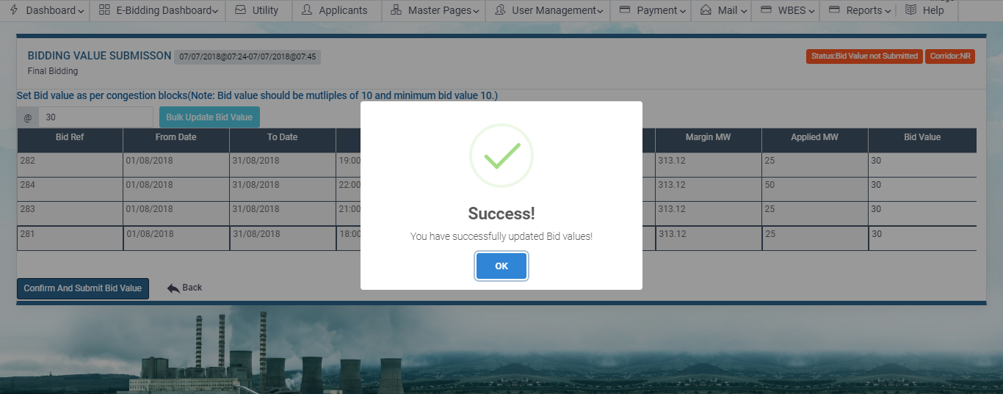

As the bid value is update the application moves to ‘PENDING BID PROCESSING’ tab

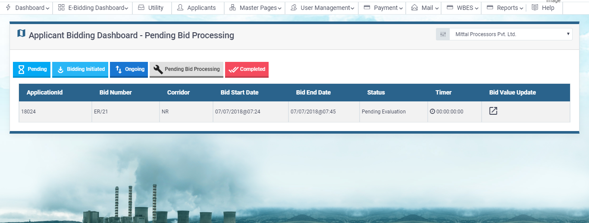

If the bidding window time period is not yet over or the bidding time is extended, applicants can re-update their bid value if required.

Downward Revision
- This is applicable only for FCFS and Advanced Applications.
- Once the application has been Approved, applicant can ask for downward revision on that application.
- In this revision application, applicants can only apply for reducing the quantum that has been approved for their requested timeblocks.
- Revision request should be submitted at least 2 days before Starting Date of the time period in which revision is required.

C.1 Request Creation :

- Click on Request Revision button to request for revision on that application.

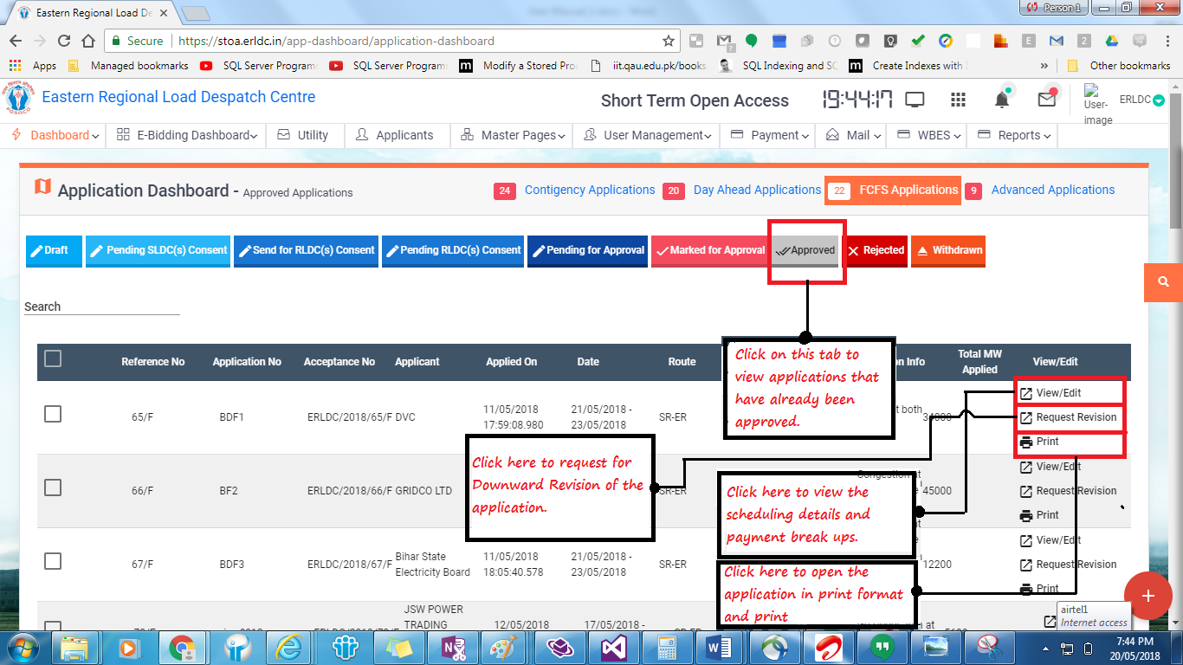

- Enter the reason for which revision is required. This is specific for Nodal RLDC only. Applicants don’t need to provide reasons for revision.

- Change the values of Revision MW column for the timeblocks in which revisions are required.
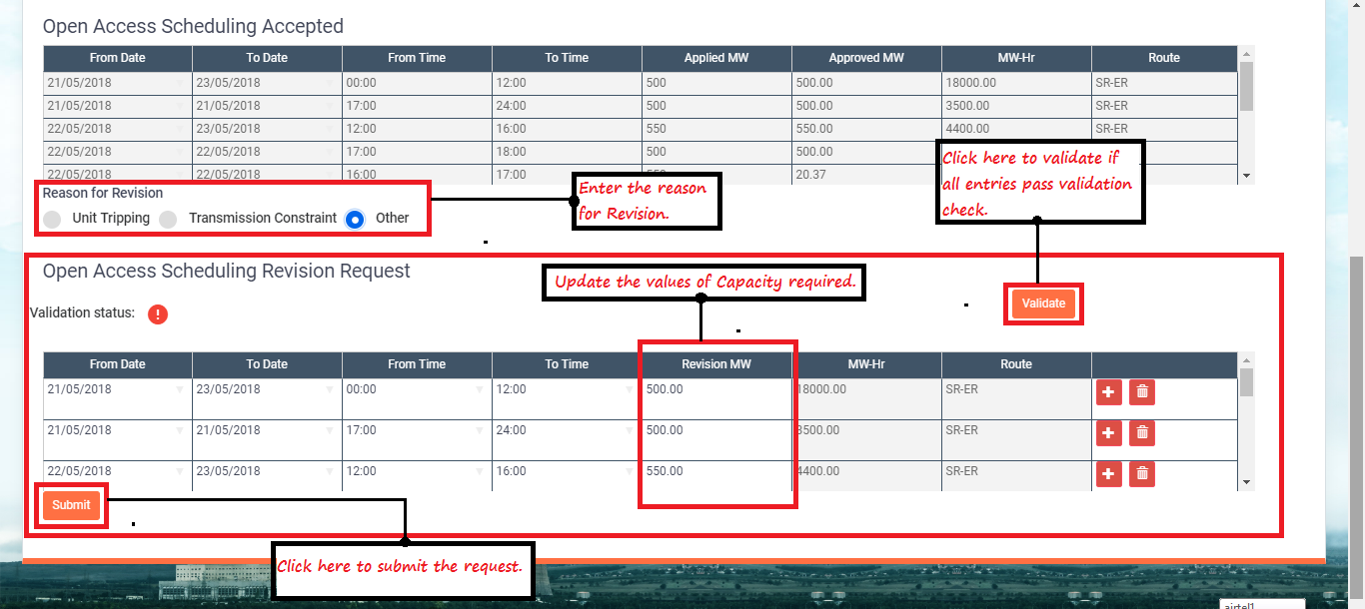

- To add more rows, click on (+) button and to delete any row click on Delete icon beside the row.

- Revision request can be submitted either by
(i) keeping the updated rows only or
(ii) Updating the already exisiting rows
e.g. : In case applicant doesn’t want no power transmission for a complete day or more than one days, he/she can create a row entering the date range in From Date and To Date fields and make Revision MW column ‘0’ for all the timeblocks starting from 00:00 to 24:00.

- After all the details have been updated, click on the Validate button to check if the entries pass all the validation rules.
If all the validations pass the (!) icon beside Validation Status will change to (√).
If the entries fail any validation check, the details will be displayed beside the Validation Status.
- Click on Submit button to submit the Revision Request.

4. Payments
For any power disbursement application that has been approved at all levels, it finally requires payment against them for disbursement of power.
The Payment section of the website tracks the history of all payments made in the system for all successful transactions.

Payment > Payment Dashboard:

- Payment Updation:
This tab shows all successful transactions for which payment needs to be initiated. Payments can be made in phases. To initiate a payment for a transaction, select the check box against it and click on next:
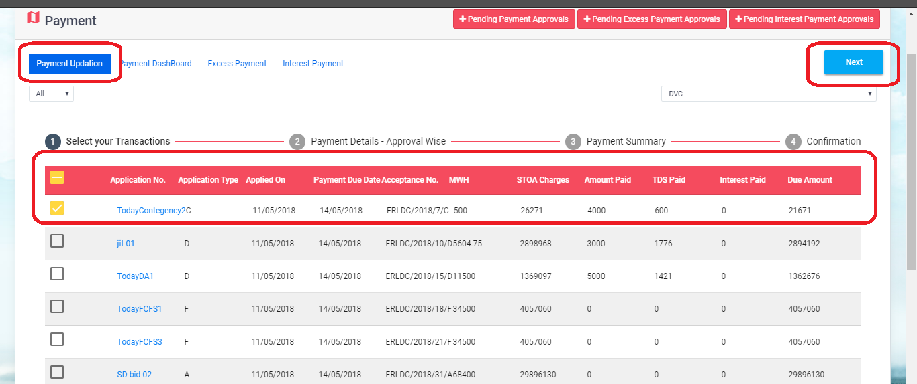

In the next screen, fill up the payment date, Paid TDS and net amount in the respective fields and then click on next. This screen shows the calculation of payments and the due amount for pay after this payment.
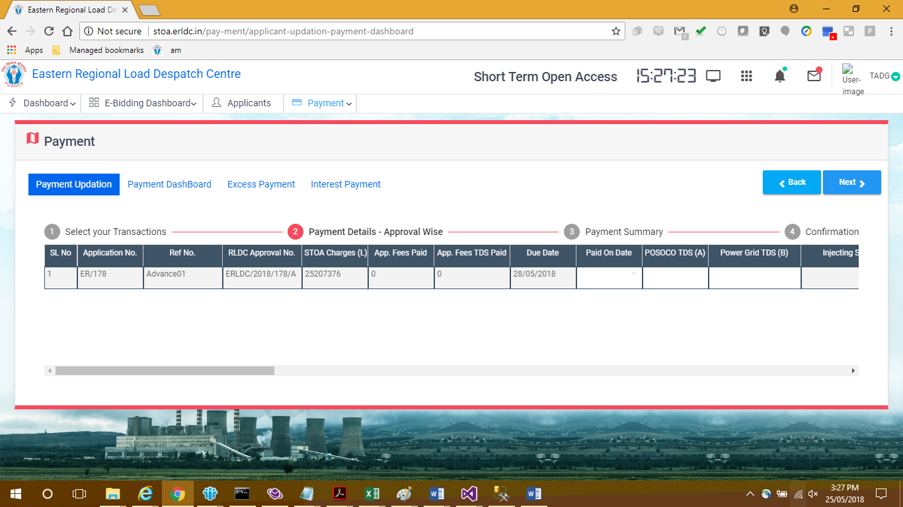

In the following screen (Payment Summary), fill up the mode of payment and bank details.
The payee can make the payment at one go or even in instalments. Select the Application ID from the drop down, Click the Add rows button to enter multiple instalment details against the same payment. There is ‘Delete Row’ button as well, to remove undesired entry from the list.
The payment mode must be either of RTGS and NEFT. The amount should be sum of the ‘Interest for delayed payment’ and ‘net amount paid’ value entered in the last screen.
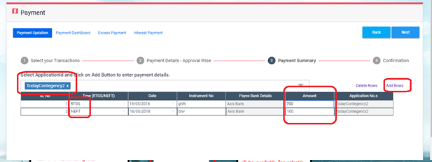

In the next ‘Confirmation’ screen, click on the submit button to finish the payment.
If the total payment amount entered in the ‘Payment Details – Approval Wise’ and ‘Payment Summary’ screen do not match, it will throw an error message that the amounts need to be same.
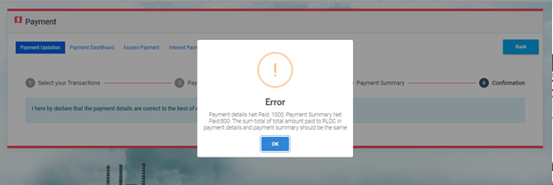

And if all amounts match and the payment is successful, it will show success message after the payment is submitted:
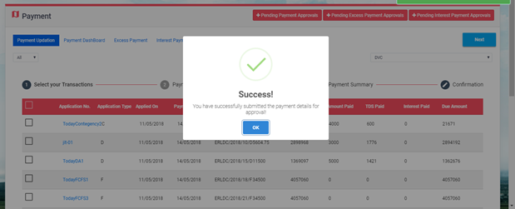

Similarly, the user can select multiple transactions and proceed on payment if desired:
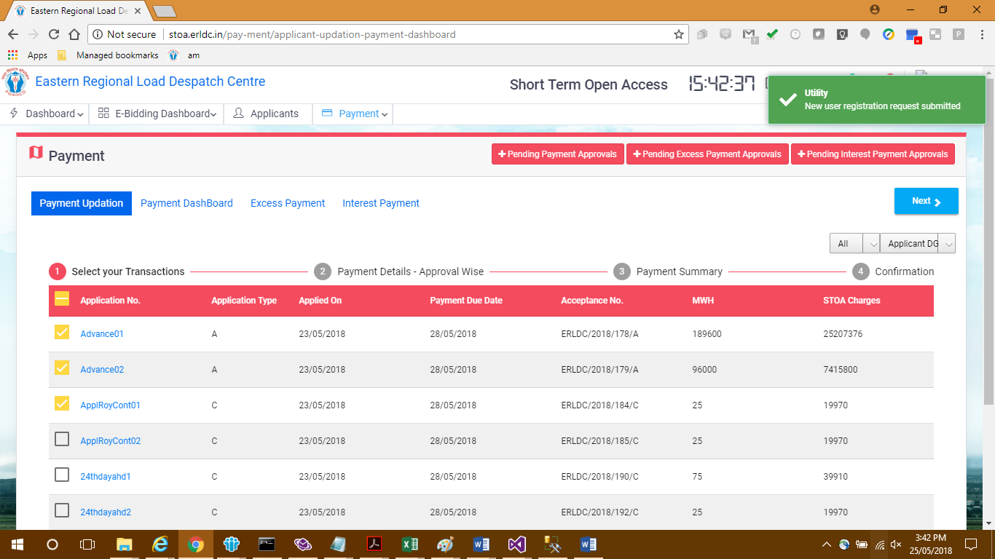

In the next tab, the list of application ids from the drop down would show all available application ids for the selected transactions:
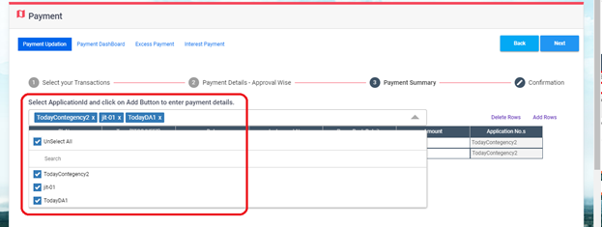

User has to select the required application id and then select ‘add Row’ so that this row gets populated with the selected application ID only at the “Application No.s’ column:
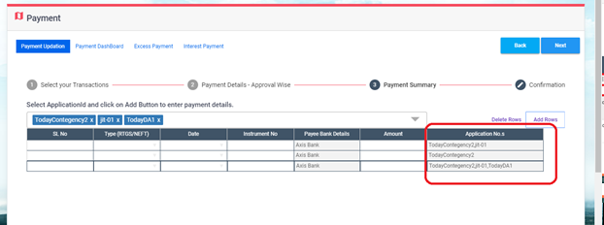

Now if a transaction is successful, RLDC has approved it, but all the due amount is not paid yet, it will move under the ‘Partial’ category.
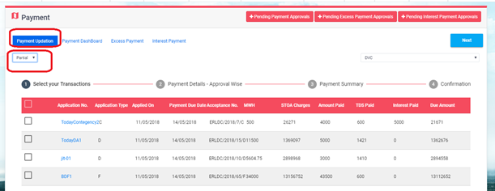

From here as well, the partially paid transactions can be initiated for further or complete payment in the same process.
The following screen would show some fields already populated due to the last payments made:
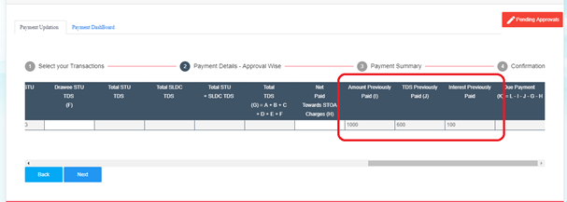

The net payment amount should be the sum of the ‘interest for late payment’ and ‘net amount being paid’ for this instalment only:
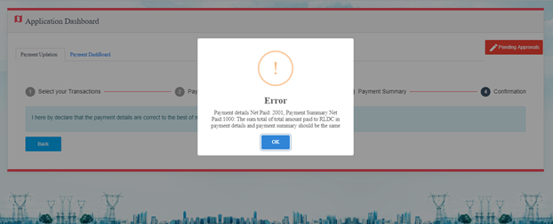

- Excess Payment:
If the user has mistakenly made some extra payment, then it can be recorded in the ‘Excess Payment’ screen:
The mode of payment must be either RTGS/NEFT. The bank details will be auto-populated and non-editable. If the user selects reason as ‘Excess Payment Towards a Particular Application’, then the user has to select the ‘Application no.’ and ‘Applicant’ from the drop-down:
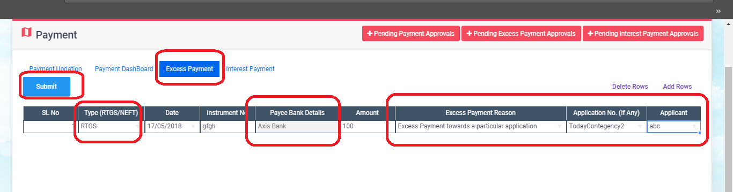

If the user selects ‘Excess Payment by mistake’, then the ‘Application no.’ must be left blank.
Finally hit the submit button.
User can add or delete rows from here as well. If inserted more rows, hitting on the ‘Submit’ button, will cause a bulk submission.
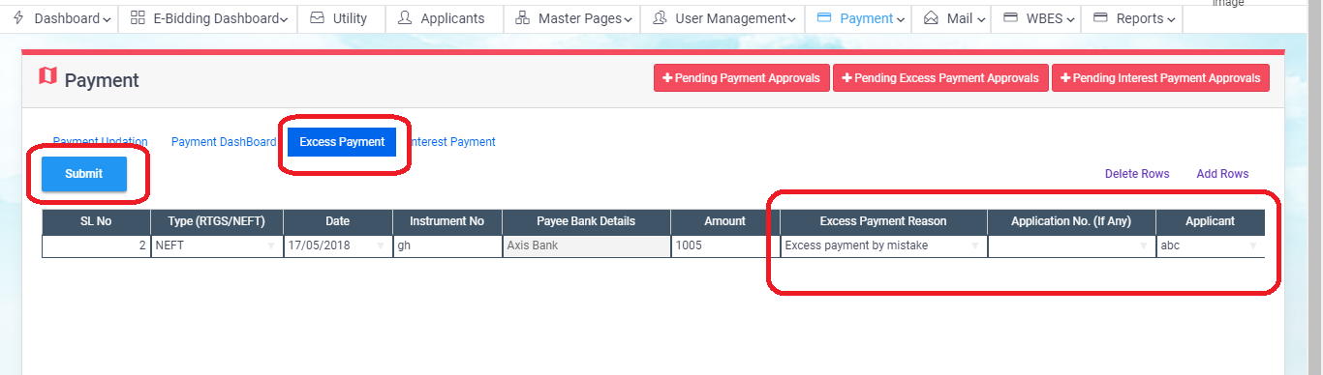

Now the Approver needs to approve the excess payment from the ‘+Pending Excess Payment Approval’ page:
User can select single or multiple applications at a go and appprove or reject the same.
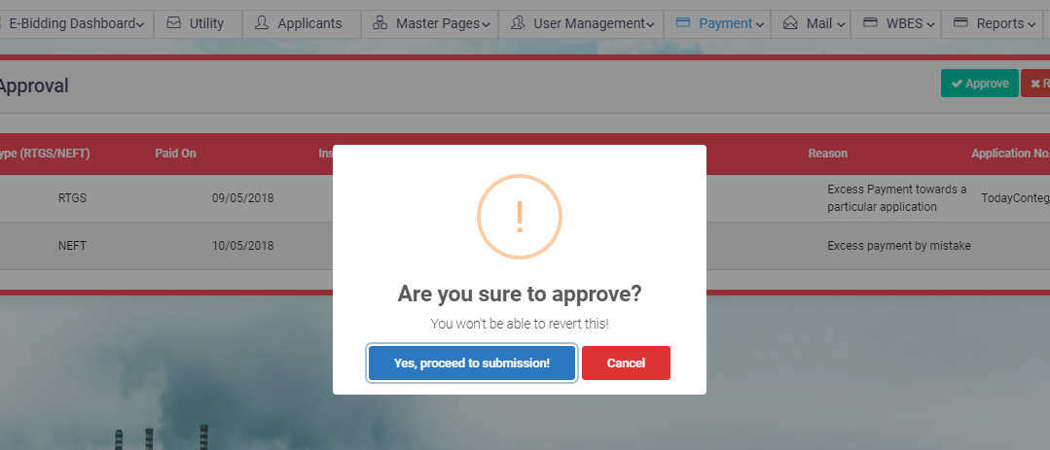

- Interest Payment
Similarly, user can pay the interest separately from the main payment and submit the details of payment from the ‘Interest Payment’ tab:
The mode of payment must be either RTGS/NEFT. The bank details will be auto-populated and non-editable. User has to select the ‘Application no.’ from the drop-down:
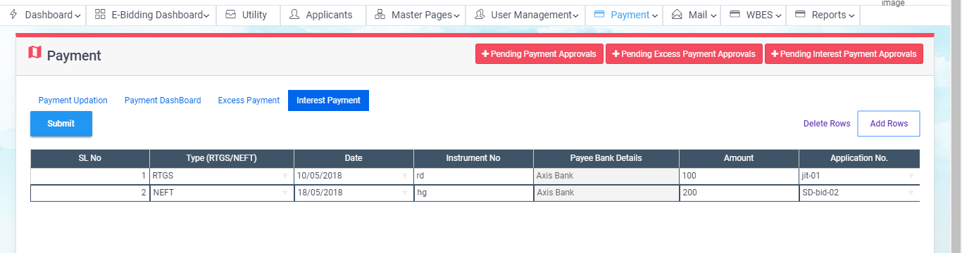

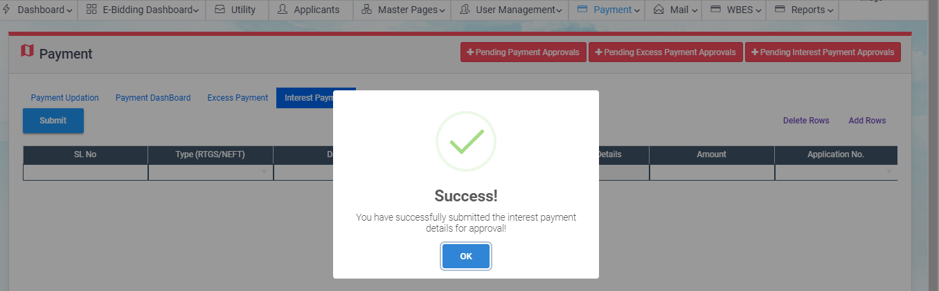

- Payment Dashboard:
    - Details Dashboard:
This is a dashboard that shows the details entered against any successful payment in the ‘Payment Details - Approval Wise’ screen of payment processing. This view shows payment details after sorting them according to the status, i.e.: Approved, rejected or all.
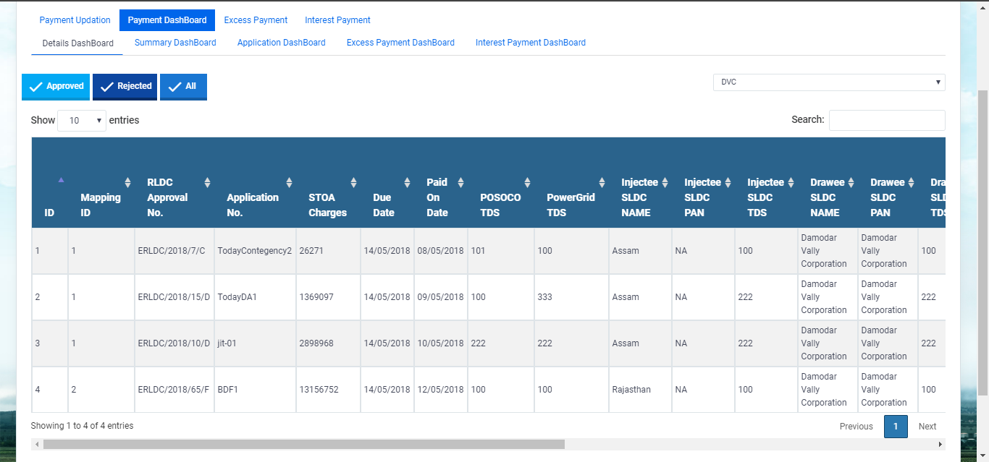

    - Summary Dashboard:
This screen shows details of the data entered in the ‘Payment Summary’ screen during payment processing. This too can be edited by admin using the edit button:

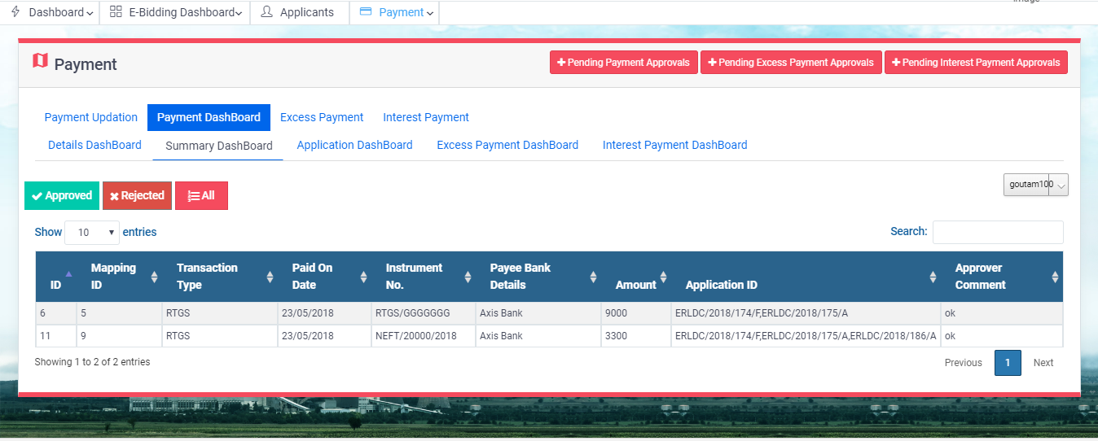

    - Application Dashboard:
This screen shows details of all payment transactions irrespective of whether it’s partial or completed.
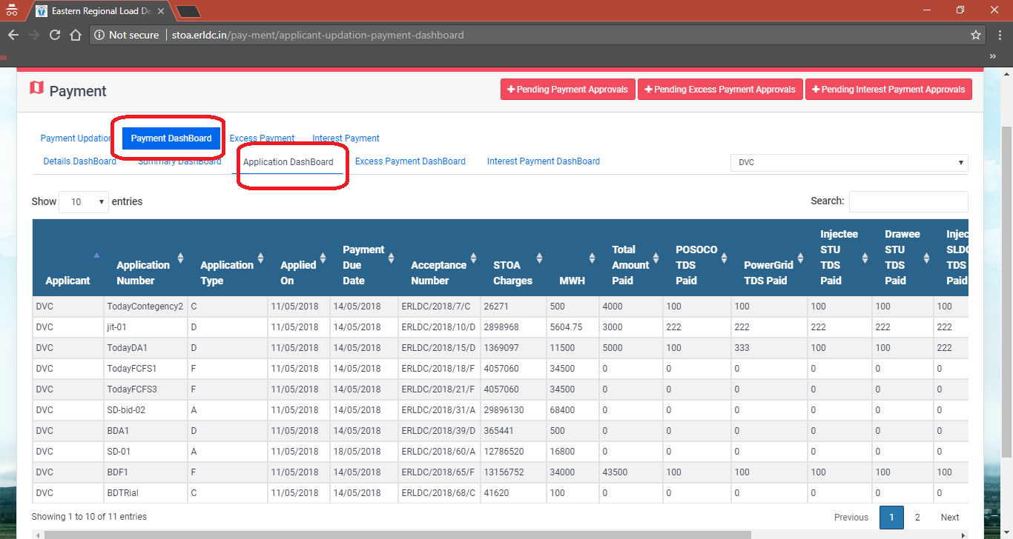

User can filter data by entering text in the search text box:
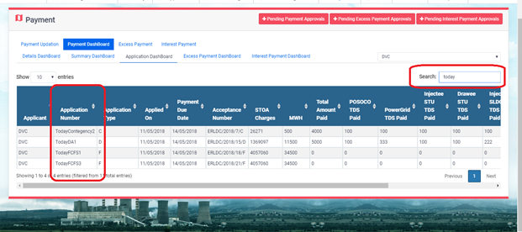

    - Excess Payment Dashboard
The excess payment requests made can be viewed from this dashboard.
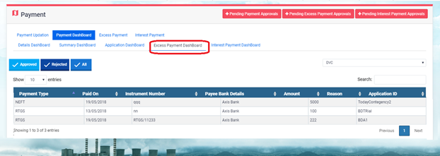

    - Interest Payment Dashboard:
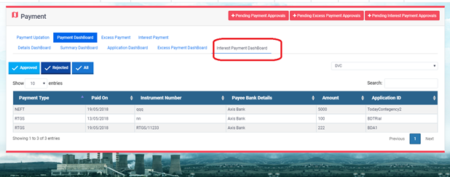

Payment > Monthly:

Monthly TDS Updation:

User needs to fill in the SLDC and STU TDS deposited amounts, their corresponding challan numbers and the Payment Dates here.
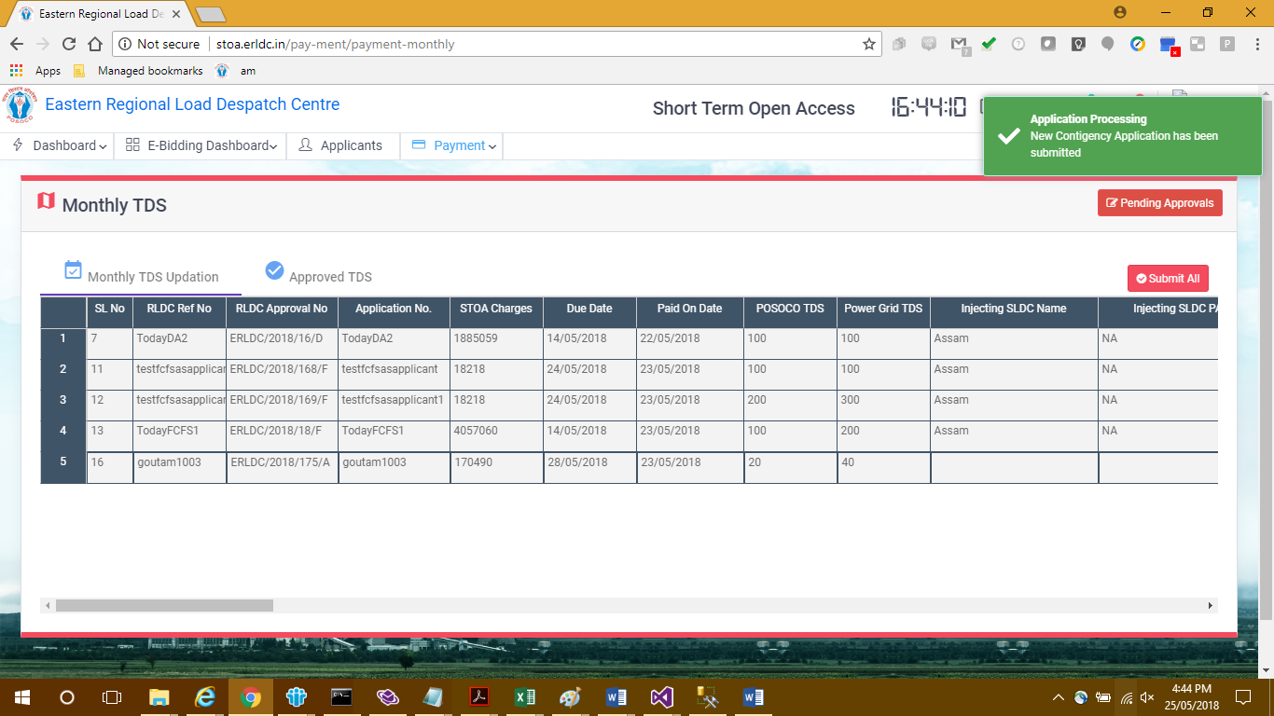

If any of the 6 TDS amount is provided against any transaction, the corresponding challan number and Payment Dates should be mandatorily put down for submitting the application. Any amount provided can not be submitted without the challan number and Payment Date.

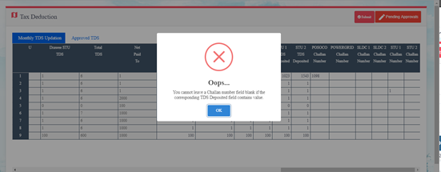

If any record has all challan numbers filled in for every TDS amount placed, it will get submitted successfully.
For all of the transactions that have proper TDS and challan number written, will get submitted altogether on hitting the ‘Submit’ button on top of the page.

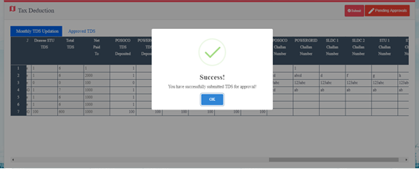

For individual submission of payment details, use the submit button at the right of each row on the page:
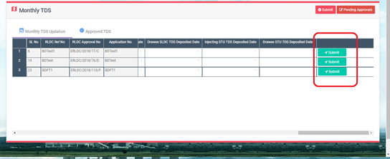

Key Contact Personnel
 | Pushpak Ghosh Dastidar  E-Mail : pushpak.ghosh.dastidar@in.pwc.com  Mob.: 9831205869  Website: www.pwc.in

